
AIR POWER COMPANY
All Types of Oxygen Gas Plant,Nitrogen Gas Plant Dryer, Ammonia Cracker, Air Dryer, Compressor & Vacuum Pumps Electrical Panel, Capacitor Panel, Fire Control Panel Manufacturing, AMC Contractor, Seal & Service, Suppliers
GST NO :- O9BAZPK5978D2ZT
Office-Plot No-4, Block-9, Pocket-7, Sector-82, Noida, 201304.
Call at: M-09810241427 Office: +91 9953252100 Email:
airpowercompanynoida15@gmaiI.com, projectaepl@ymail.com, jaykishore828@gmail.com.

PROPOSAL

QTN/O2/50B/APC/26-27 /51 DATE : 12/05/2026

To, Mr M. Mageswara Rao(Kanker)M-9685072209

Subject: Offer for PSA Oxygen Gas Generator – 10 NM3/hr Capacity
Dear Sir/Madam,
We refer to the discussions held regarding your requirement for an onsite PSA Oxygen Gas Generator system. We are pleased to submit our techno-commercial offer for a 10 NM3/hr Oxygen Gas Generator with oxygen purity ranging from 93% to 95%.

ABOUT US
We are an engineering organization specializing in the design, manufacture, supply, installation, and commissioning of:
- On-site Oxygen & Nitrogen Gas Systems
- Compressed Air Systems (CAS)
- Air Dryers & Air Receivers
- Gas & Moisture Analyzers
- Oxygen Storage Tanks
- Portable Oxygen Analyzers
We have more than 10 years of experience and successfully installed more than 150 gas plants across India.

PSA OXYGEN GENERATOR SYSTEM

Features
- Onsite oxygen generation from compressed air
- Oxygen purity: 93% to 95%
- Fully automatic PLC-based operation
- Online oxygen analyzer with purity interlock
- Low operating cost
- Compact and maintenance-friendly design
- Pre-piped, pre-wired & factory-tested system
- Continuous oxygen supply system
- Suitable for industrial and medical applications

TECHNICAL SPECIFICATIONS

Description | Details
Equipment | PSA Oxygen Gas Generator
Model | ZMS Type
Oxygen Capacity | 10 NM3/hr
Oxygen Purity | 93% to 95%
Working Pressure | 3.5 Kg/cm²
Dew Point | (-)40°C
Oxygen Outlet Pressure | 3.5 – 4.0 Kg/cm²
Plant Operation | Fully Automatic
Installation | Indoor
Technology | PSA (Pressure Swing Adsorption)

PRODUCT GAS SPECIFICATION
Gas | Specification
Oxygen (O2) | 93% to 95%
Nitrogen & Other Gases | Balance
Oil Content | Nil
Moisture | Dry Gas

SYSTEM DESCRIPTION

1. Screw Air Compressor
- Air cooled screw compressor
- Automatic ON/OFF operation
- Heavy duty industrial application

2. Compressed Air Treatment Unit
- Wet air receiver with auto drain valve
- Moisture separator
- Oil removal filters
- Refrigerated air dryer
- Fine filters

3. PSA Oxygen Module
Twin tower PSA system filled with:
- Activated Alumina
- Zeolite Molecular Sieves (ZMS)
The system automatically performs adsorption and regeneration cycles for continuous oxygen production.

4. Online Oxygen Analyzer
- Continuous purity monitoring
- Alarm and auto vent system
- Purity safety interlock

5. Oxygen Storage Tank
- Capacity: 2000 Ltr
- Working Pressure: 3.5–4.0 Kg/cm²
- Complete with safety valve & pressure gauge
- Booster Air Compressor

UTILITIES REQUIRED (CLIENT SCOPE)
- RCC foundation/platform32A 4P
- Main electrical cable connection(Copper10mm)
- Earthing work (Copper wire 4mm)
- Shed/room for installation
- Electrical MCCB

Power Requirement
- Voltage: 440V AC, 3 Phase, 50Hz
- Connected Load: Approx. 15 KW
Component | Make
Screw Compressor | CompAir / ELGi / IR
Air Dryer | IR / APC
Filters | Concept
Oxygen Module | APC
Valves | Janatics
Oxygen Analyzer | Nucon / Viraj
Storage Tank | APC
Electrical Panel | APC

MAKE OF MAJOR COMPONENTS

SPACE REQUIREMENT
Description | Dimension
Length | Approx. 4.0 Meter
Width | Approx. 1.5 Meter
Height | Approx. 2.8 Meter

COMMERCIAL OFFER

Sr. No. | Description | Qty | Amount
1 | Screw Air Compressor with Air Dryer & Filters | 1 Set | Included
2 | PSA Oxygen Gas Generator – 10 NM3/hr | 1 Set | Included
3 | Oxygen Storage Tank – 2000 Ltr | 1 Set | Included

TTotal Offer Price: Rs. 11,20,000/-
(Rupees Eleven Lakh Twenty Thousand Only)

TERMS OF PAYMENT
- 40% Advance along with Purchase Order
- 55% Against Proforma Invoice before dispatch
- 05% After Installation & Commissioning

DELIVERY
Delivery shall be made within 3 to 4 weeks from the date of receipt of confirmed Purchase Order and advance payment.

TAXES & DUTIES
- GST @ 18% Extra
- Freight Extra
- Packing & Loading Extra
- Prices are Ex-Works Noida

INSTALLATION & COMMISSIONING
- Installation & Commissioning included (within India)
- Standard commissioning period: 5 days
- Accommodation and local support for engineer shall be in client scope
- Extra days beyond 5 days shall be charged additionally

GUARANTEE
- 12 Months warranty against manufacturing defects
- ZMS life expectancy: 5 years (subject to proper operating conditions)
Thanking you and assuring you of our best services at all times.
Offer validity only 6 Month.

Yours Faithfully,
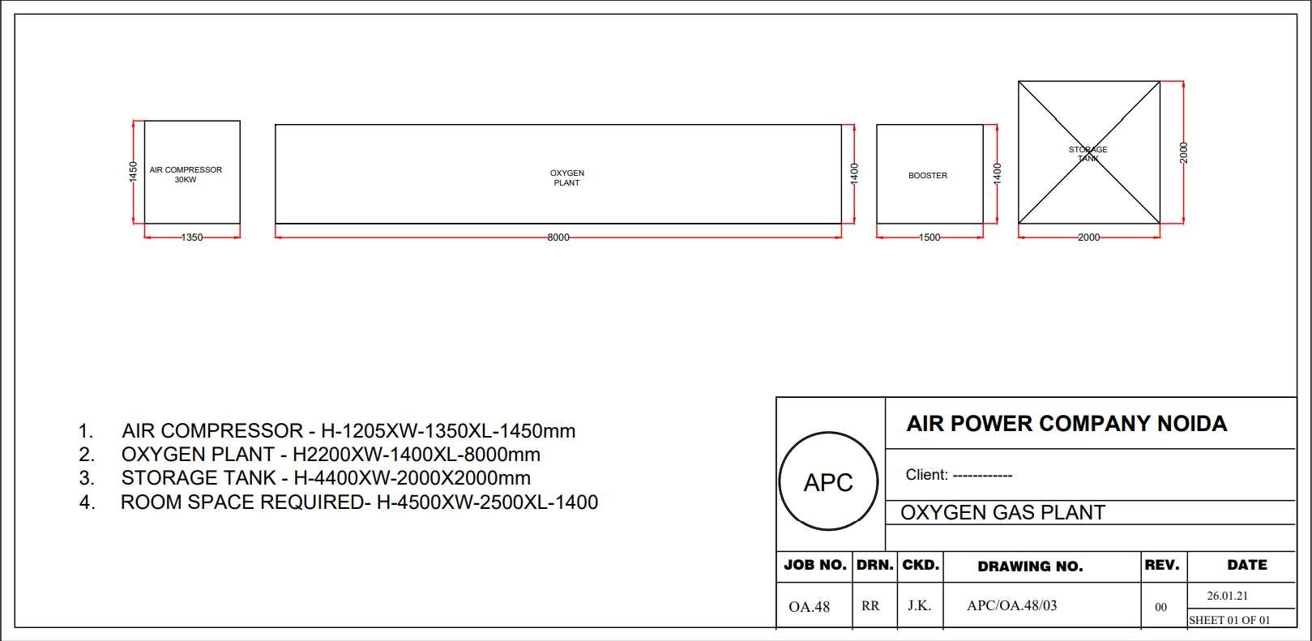

Work Address:

Air Power Company
Near Plot No-341

Udyog Kendra-I, Ecotech-III
G.B Nagar Noida 201 306. INDIA GST No : 09BAZPK5978D2ZT

E-mail : airpowercompanynoida15@gmail.com

